Assesssment 1 - COVID-19 impact on digital learning

Provide Student Name and Student ID

2024-03-17

## 1. Data Cleaning and Wrangling

**Describe and show the data cleaning, transformation and wrangling process’ that you have completed. Ensure you provide justification of any data handling and transformation you have completed.**

you can embed your transfomration code and provide justification like this:

example: This code creates x and y variable, i have created these variable so that i can add these to my data frame and compute the required measures. Please remember to use comments in your code.

x <- 1:10 # create an x variable  
y <- 10:1 # create a y variable  
dataf <- data.frame(x = x, y = y)  
  
summary(dataf)

## x y   
## Min. : 1.00 Min. : 1.00   
## 1st Qu.: 3.25 1st Qu.: 3.25   
## Median : 5.50 Median : 5.50   
## Mean : 5.50 Mean : 5.50   
## 3rd Qu.: 7.75 3rd Qu.: 7.75   
## Max. :10.00 Max. :10.00

## 2. Data Visualisation

**Provide evidence of your visualisation techniques and the reason for your choice of visual tools. Provide a description of each visualisation you are presenting. There is no need to show your code.**

You can also embed plots, and provide reason for your choice like this:

example: I have used the below visualisation technique because ….

This visualisation shows the following…

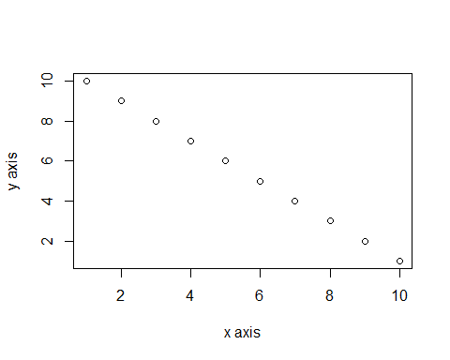

## 3. Findings

**Clearly explain your findings and provide a valid conclusion of your analysis. References may be used if required.(max 500 words)**